PGE 392K In Class Assignment

Nov 5, 2020

1. Complete your 1D component transport code that has the following features
   1. Input file that defines number of grids, well locations and type (injector or producer), NPe, initial concentration, pressure field (defined directly or read in from a text file), final dimensionless time/PVI and , ,  scalar values
   2. “Arrays” subroutine/function that creates your **, ,  **
   3. Main file which calls the arrays and input file and then loops through time to explicitly solve for concentration in each grid at different times (use a timestep of 0.01). Note you will need to be updating your C* matrix as well
   4. Postprocess by plotting concentration versus distance (x=0 to 1) at three dimensionless times, 0.2, 0.5, 1
2. Test your code using N=5 grids, Npe= 1000;      and the following two conditions the four conditions described in the power point notes to get the same **, , ** You will need to make up pressures for the flow direction to perform the upwinding.
3. Test your code using N=101 grids, Npe= 1000;      and final dimensionless time =2. Make plots for the same 4 cases in #2. Results below

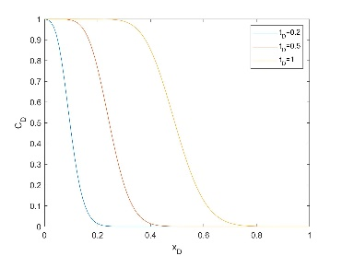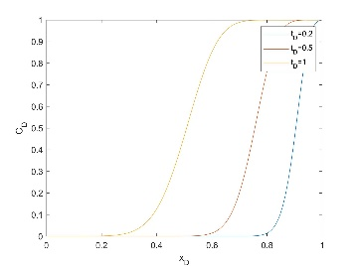

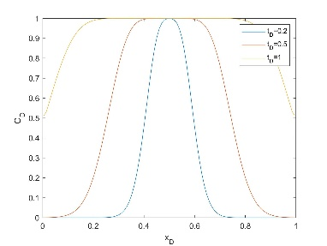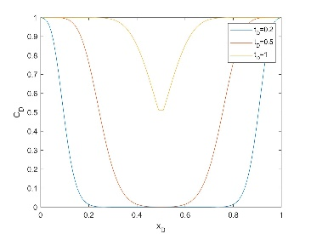

1. Adapt your 1D code to calculate the Courant matrix by computing the velocity using Darcy’s law and the pressure field
2. Adapt your code for 2D problems and then test your code for a 3x3 grid with an injector in the bottom left corner and producer in upper right corner. Repeat for a 30 x 30 grid